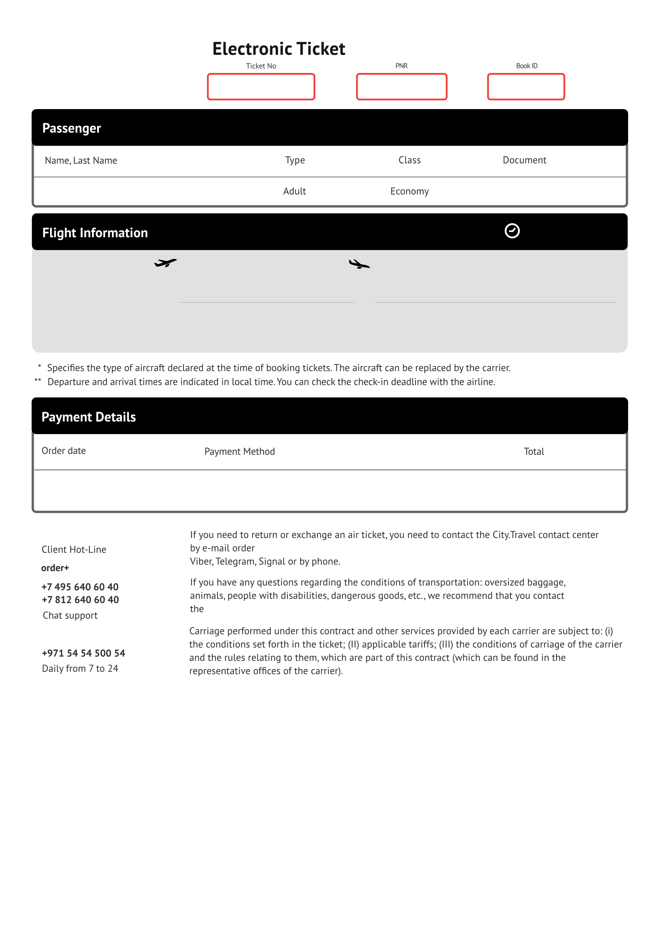

Ryanair by phone: +1-805-519-5390

+6512487@city.travel in free form, chat customer support via WhatsApp,

**6512487@city.travel**

Bank card

**73,77 EUR**

13.04.2023 20:45

**FR-4084**

**Ryanair**

*Boeing 737-800*

**KRK**

***Krakow***

Krakow, Poland

**21:25 6 may 2023\*\***

*To the city center 11 км*

**TLV**

***Ben Gurion***

Tel Aviv, Israel

**18:40 6 may 2023\*\***

*Check-in until17:40\*\**

**6512487**

**6488548512565**

**F2D3V7**

**FG672057**

**3 h 45 min on the way**

**OZHHO YAROSLAV** 22.09.1995